**Name : Kumar Ayush**

**Roll : 21051737**

**CSE-18**

**OPP Lab Assignment : 3**

1. **WAP to find the area of a circle, a rectangle, and a triangle, using the concept of function overloading.**

#include <iostream>

#include <math.h>

using namespace std;

void area(int r);

void area(int l , int b);

void area(int a , int b , int c);

int main(){

    int r , a , b , c , br , l ;

    printf("\n\n------------------for triangle--------------------\n\nenter the length of three sides of triangle : ");

    cin>>a>>b>>c;

    area(a , b , c);

    printf("\n\n------------------for circle--------------------\n\nenter the radius length of the circle : ");

    cin>>r;

    area(r);

    printf("\n\n------------------for square--------------------\n\nenter the length of adjecent two sides of a square : ");

    cin>>l>>br;

    area(l , br);

    return 0;

}

void area(int r){

    float a;

    a=3.14*r*r;

    cout<<"\n\n\tarea of cicle is : "<<a<<"unit^2";

}

void area(int l , int b){

    int a;

    a=l*b;

    cout<<"\n\n\tarea of rectangle is : "<<a<<"unit^2";

}

void area(int a , int b , int c){

    float ar,s;

    s = (a+b+c)/2;

    ar = sqrt(s*(s-a)*(s-b)*(s-c));

    cout<<"\n\n\tarea of triangle is : "<<ar<<"unit^2";

}

**OUTPUT**

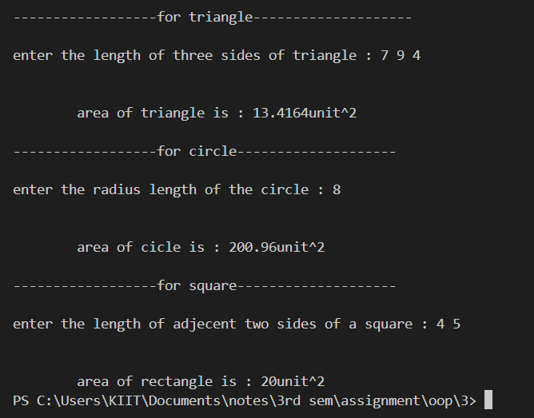

**2. WAP to find the volume of a sphere, a cylinder, and a cuboid, using function overloading.**

#include <iostream>

#include <math.h>

using namespace std;

void vol(int r);

void vol(int l , int rc);

void vol(int a , int b , int c);

int main(){

    int r , a , b , c , rc , l ;

    printf("\n\n------------------for cuboid--------------------\n\nenter the length width and height of a cuboid respectiely : ");

    cin>>a>>b>>c;

    vol(a , b , c);

    printf("\n\n------------------for circle--------------------\n\nenter the radius length of the circle : ");

    cin>>r;

    vol(r);

    printf("\n\n------------------for cylinder--------------------\n\nenter the height and radius of cylinder respectively : ");

    cin>>l>>rc;

    vol(l , rc);

    return 0;

}

void vol(int r){

    float a;

    a=4/3*3.14*r*r*3;

    cout<<"\n\n\tvolume of cicle is : "<<a<<"unit^3";

}

void vol(int l , int rc){

    float v;

    v=3.14*rc*rc*l;

    cout<<"\n\n\tvolume of cylinder is : "<<v<<"unit^3";

}

void vol(int a , int b , int c){

    int v;

    v=a*b*c;

    cout<<"\n\n\tvolume of cuboid is : "<<v<<"unit^3";

}

**OUTPUT**

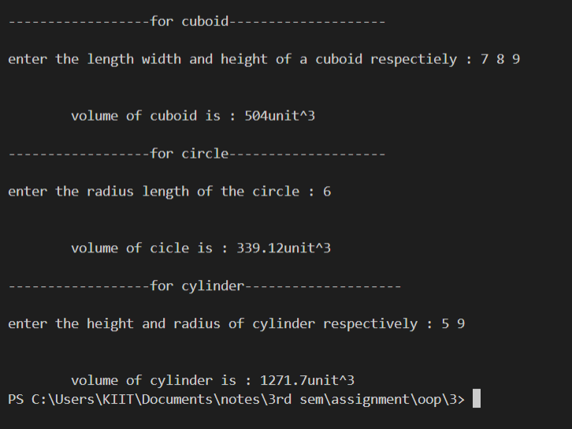

**3. WAP, which displays a given character, n number of times, using a function. When the n value is not provided, it should print the given character 80 times. When both the character and n value are not provided, it should print ‘*’ character 80 times.  
[Write the above program in two ways:-  
-using function overloading.  
-using default arguments.]**

#include <iostream>

using namespace std;

void pattern(char = '*', int = 80);

//void pattern(char ch , int n);

int main(){

    char ch;

    int n;

    cout<<"enter the character and no. of itteration respectively : ";

    cin>>ch>>n;

    pattern(ch,n);

    printf("\nwithout passing arrgument \n");

    pattern();

    return 0;

}

void pattern(char ch , int n){

    for(int i=0 ; i<n ; i++)

    cout<<ch;

}

**OUTPUT**

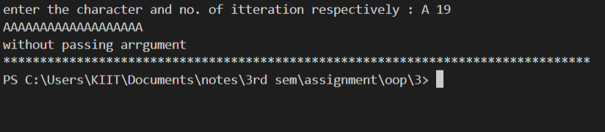

**4. WAP to find the square and cube of a number using an inline function.**

#include <iostream>

using namespace std;

inline void f1(int n);

int main(){

    int n;

    cout<<"enter the number : ";

    cin>>n;

    f1(n);

    return 0;

}

inline void f1(int n){

    cout<<"\ncube = "<<n*n*n<<" square = "<<n*n;

}

**OUTPUT**

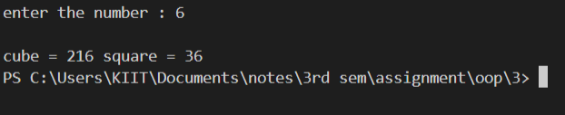

**5. WAP to swap two integers using pass by reference.**

#include <iostream>

using namespace std;

void swap(int *a , int *b);

int main(){

    int a , b;

    cout<<"enter a and b repectively : ";

    cin>>a>>b;

    cout<<"before swaping : a="<<a<<"and b="<<b;

    swap(&a,&b);

    return 0;

}

void swap(int *a , int *b){

    int temp = *a;

    *a=*b;

    *b=temp;

    cout<<"\nafter swaping a = "<<*a<<" b = "<<*b;

}

**OUTPUT**

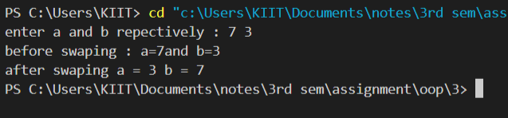

**6. WAP to increment the value of an argument given to the function**

#include <iostream>

using namespace std;

void f1(int n);

int main(){

    int n;

    cin>>n;

    f1(n);

    return 0;

}

void f1(int n){

    n++;

    cout<<endl<<n;

}

**OUTPUT**

